BCC GEOSPATIAL CENTER OF THE CUNY CREST INSTITUTE
[Office of Academic Affairs]

Annual Report
2021 - 2022

Activities

Fall 2021

During the fall, 3 graduate students were mentored and trained in research relating to carbon sinks and emissions, as well as river quality and flooding. Each student has expert mentorship and guidance from the center and uses industry standard software such as ENVI, ArcGIS, and QGIS for their spatial analyses. A sample abstract of one of the projects our interns performed is below.

Abstract:

Develop methodology for rapid mapping of disaster prone area using time-series of Sentinel Level 2A surface reflectance products over Uttarakhand, India, a state ravaged by flash floods. The second project will require the intern to develop a strategy to decarbonized New York City (buildings) using available geospatial datasets and open source software (based on the meeting and discussions with the mentor). The methodology must include a strategy to analyze and model open source datasets that are available for public good from the NYC.gov data hubs for developing a decision support system that will facilitate implementation of the decarbonization project.

Research Intern Profiles

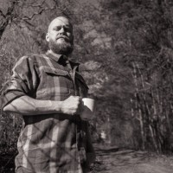
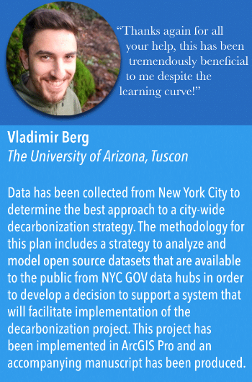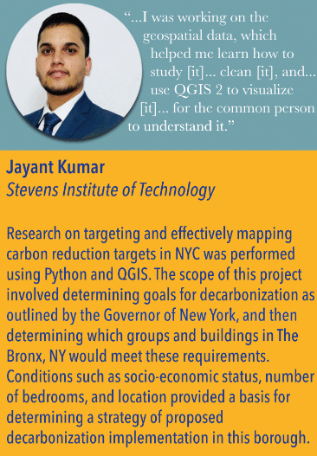
James Aaron
University of North Carolina at Wilmington

The land use land cover between 2018 and 2020 was analyzed among 4 different rivers and compared By looking at how the Sentinel 2 satellite images changed from over the 2 years and researching each respective area, the study was able to conclude human factors that contributed to the deterioration of rivers and what could potentially be done to stop it.
“I would like to thank
my mentor
[Dr. Sunil Bhaskaran]
for the valuable
feedback he provided.”

Spring 2022 activities are currently ongoing

Fostering Multi-Disciplinary Research and Collaborations at Bronx Community College

The Center is always looking to collaborate and grow, which is why a collaboration meeting with the Digital University of Kerala took place at the end of 2021. During this meeting, members from BGCCCI and DUK met and presented their work, accomplishments, and future goals and ideas in furthering geospatial programs and education. Presentations ranged from LiDAR systems to hydrographic information systems, with details discussions and plans on implementations, growth, and next steps.

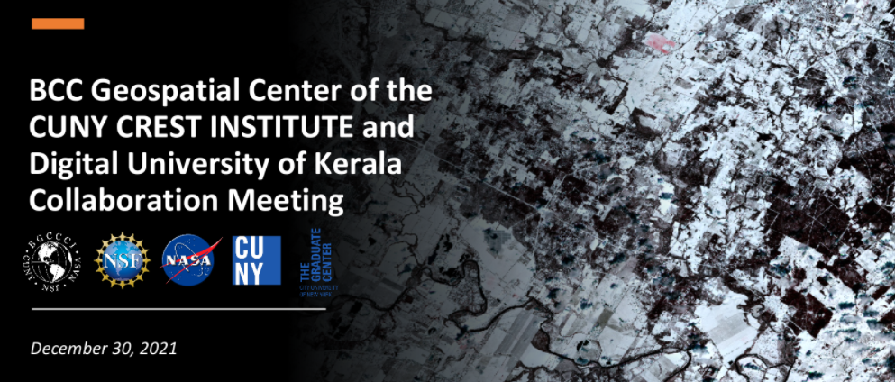

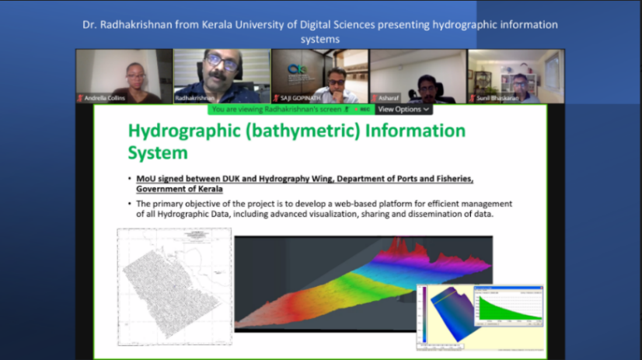
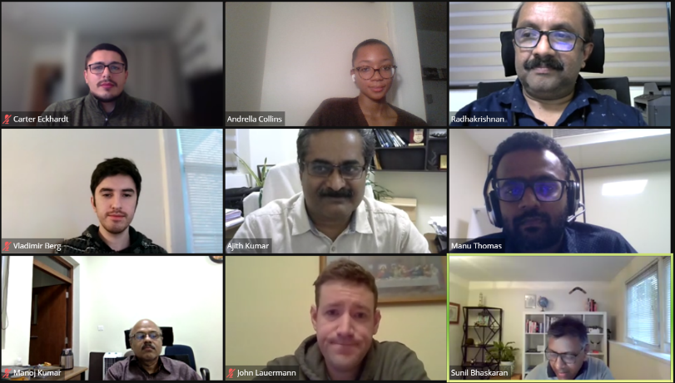

Grant Awards

How do BGCCCI activities align to BCC-CUNY Strategic Plans and Goals?

The overarching vision of Bronx Community College is to effectively invest in each student’s success by engaging with them in an integrative and supportive environment that facilitates the development and achievement of their educational and career goals. Graduates will be prepared to understand, thrive in, and contribute to a 21st - century global community marked by diversity, change, and expanded opportunities for lifelong learning and growth. Since its inception, BGCCCI has been demonstrating that all activities conducted by it in the past were aligned with this overarching institutional plan. The following goals are outlined below, and all of BGCCCI’s future plans are intended to align with one or more of these goals. As the center has been awarded major grants from NSF and NASA, along with the high success rate in getting external funds, the proposed collaborations will help the center to grow further and create a unique brand image within the College University of New York system, and within the NYC Metropolitan region.

Description of Proposed Activities | Alignment to BCC-CUNY Strategic Plans
Fostering multidisciplinary projects  with BCC academic departments. | Goal #3: Deepen student learning {Promotes integrated faculty learning, promotes and encourage excellent teaching and scholarship.
Undertaking cutting-edge  undergraduate & graduate research projects with internal and external clients. | Goal #3: Promote and encourage excellent teaching and scholarship.
Workshops for middle and high schools. | Goal #3: Deepen student learning {Promotes integrated faculty learning, promotes and encourage excellent teaching and scholarship.
Expert workshops for BCC students. | Goal #5: Cultivate a 21st Century Curriculum {strengthen program outcomes by maintaining formal linkages with four-year colleges and industry.
Delivering workshops for the community | Goal #7: Promote a reputation for excellence  1. Build and promote a brand around a learning-centered culture.  2. Promote pride in BCC.  3. Engage faculty, staff, students, alumni and supporters in telling  their BCC success stories.  4. Illustrate BCC as a premier institution with branding messages  and media sources.
Internships, Workshops, and International Conferences | Goal 7: Promote a reputation for excellence  1. Build and promote a brand around a learning-centered culture.  2. Promote pride in BCC.  3. Engage faculty, staff, students, alumni and supporters in telling their BCC success stories.  4. Illustrate BCC as a premier institution with branding messages and media sources.

Goal 1: BGCCCI BUILDS A COMMUNITY OF EXCELLENCE.
• Implement and carry out Workshops for Middle, High, and Undergraduate Students, as well as Professional Educators and members of the community.
• Provides opportunities for Graduate and Undergraduate students to work in BCC Geospatial Center of the CUNY Crest Institute and acquire workforce skills.
• Collaborates with an Industry consortium to design curricula, programs out-of-the-box Internships and career pathways.
• Designing, developing and introducing new and multidisciplinary courses/programs in geospatial technology.
• Fostering and Increasing Participation in Geospatial Technology and STEM for a diversity of underrepresented groups.

Goal 2: BGCCCI EMPOWERS STUDENTS TO SUCEED IN THEIR CHOSEN CAREERS OR HIGHER EDUCATION.
• Guest Speakers from Industry relating to Geospatial Technology speak with Workshop participants regarding furthering education and career pathways. • Allow student participation and hands on training in Geospatial Technology.
• Teach geospatial application skills, furthering knowledge in various areas with implications to further career and education paths.
See Link >>> http://www.bcc.cuny.edu/academics/geospatial-center-of-the-cuny-crestinstitute/bgccci-advisory-board/

Goal 3: BGCCCI DEEPENS STUDENT LEARNING.
• Conducting scholarly activities and cutting-edge research in areas of national priority.
• Training students in acquiring workforce skills by organizing summer institutes for school and college students.
• Creating innovative pathways in geospatial technology and career pathways.
• Publishing in peer-reviewed journals and proceedings of conferences.

Goal 4: BGCCCI DEVELOPS WORLD CITIZENS.
• Students conduct research using satellite data and geographic data on translational topics of global importance such as Urbanization, Land Cover, Feature Extraction, BIG Data analytics.
• Affiliated faculty and students at BGCCCI and other institutions across the nation connected through BGCCCI and the learning of geospatial technology.

Goal 5: BGCCI CULTIVATES A 21ST CENTURY CURRICULUM.
• Promotes education and research in emerging Geospatial Technology.
• Affiliated faculty at BGCCCI design curriculum that is focused on place-based, hands-on learning experiences that enhance spatial thinking and cognition in key areas of geographic information systems, remote sensing, and global positioning systems.
• Geospatial Pathway courses have a cumulative enrollment of approximately 300 students since Fall 2015

Goal 6: BGCCCI ENHANCES THE CAMPUS ENVIRONMENT.
• Promotes cutting-edge research using data from the office of Institutional research to create interactive user friendly spatial information systems.
• Show a replicable model of space and resource usage versus measurable outcomes.
• Use of the Geospatial Center in optimally carrying out workshops, and research.

Goal 7: BGCCCI PROMOTES A REPUTATION FOR EXCELLENCE.
• Affiliated faculty and experts mentor students in cutting-edge research.
• Affiliated faculty conduct cutting-edge research that is published in peer-reviewed journals.
• Affiliated faculty has a high success ratio in securing grant funding from federal and private agencies.
• Affiliated faculty deliver presentations at departments to foster multi-disciplinary applied research.
• New curricula, programs, hands-on learning materials using industry standard suite of software and satellite data.
• Interns from other institutions conduct cutting-edge research
• Guest lectures by experts in the Industry.
• History of collaborating with an Industry consortium to create career pathways.
• Collaborate with all stake holders to increase participation of underserved communities and inclusiveness in geospatial technology.
• Hosts information sessions and workshops for visiting delegations including Fulbright Scholars, and dignitaries

Budget – Fiscal 2021

Budget Category | Details | Total Amount | Funding from College | Funding from CUNY | Funding from Grants and Awards | Other Funds
Personnel
Director | Summer Salary [Includes $37,635 from federal grants + adjunct replacement at $4,530 per course] | $55,755 | $18,120 Reassigned time of 12hr. [6hrs for spring and 6hrs for Fall] from OAA | - | $37,635 | -
Staff | Administrative Support [To assist the director in managing the geospatial center and two major federal grants for the College] | $41,235 | $15,600 | - | $25,635 | -
Stipends |  | $96,990 | $33,720 |  | $63,270
Total Personnel | - | - | - | - | - | -
Other than Personnel Services (OTPS) | - | - | - | - | - | -
Travel | - | $9,470 | - | - | $9,470 | -
Stipends | For participants in NSF & NASA workshops | $255,900 | - | - | $255,900 | -
Equipment | - | - | - | - | - | -
Supplies | - | - | - | - | - | -
Other | - | - | - | - | - | -
Total OTPS |  | $287,846 |  |  | $287,846

BGCCCI Assessment Metrics

All activities are assessed by using formative and summative model of assessment. Activities are evaluated and assessed by assessment metrics (see below) as well as by an external evaluator.

Description of Activities | Assessment Mode
- Workshops and training | Survey
- Research | Publications – journals, reports, conference presentations
- Seminars | Survey
- Internships | Project completion
- Sponsored Events | Survey & Feedback form
- Geospatial Computing Center | Space use
- International Collaborations | Project results, publications, reports
- National Collaborations | Project results, publications, reports
- Center support for college and CUNY | Survey
- External Grants | Grants Awarded

BGCCCI Quick Look fact sheet [2014-]

BCC Geospatial Center of the CUNY CREST Institute [BGCCCI] is a unit under the Office of Academic Affairs. Reports to the Interim Provost of BCC-CUNY – Dr. Luis Montenegro

141 Middle School Workshop participants
155 High School Workshop participants
31 Undergraduate Workshop participants
71 SWIP Research Interns
35 Professional Development Workshop participants

433 Total Participants (as of 2/6/22)

Founding Director – Professor Sunil Bhaskaran
Web site: http://www.bcc.cuny.edu/academics/geospatial-center-of-the-cuny-crest-institute/
Twitter @BGCCCIGeo
Part time Staff: Andrella Collins
Full Time Staff:

