BCC GEOSPATIAL CENTER OF THE CUNY CREST INSTITUTE
[Office of Academic Affairs]

Annual Report
2020 - 2021

Activities

Summer 2020

In the summer of 2020 during the unprecedented times of the COVID-19 pandemic, through collaboration and support from the Industry Consortium, the Center was able to hold two virtual programs over the summer. Those were the Summer Workforce Internship Program for high school and university students, and the Professional Development Workshop for educators and teachers. These high school students, university students, and educators were afforded the opportunity to further their knowledge and understanding of geospatial technology with hands on activities and exercises.

Over the course of several weeks during the 2020 Summer Workforce Internship Program, 21 interns at both the high school and university level were able to remotely research topics related to geospatial technology, which cumulated in technical reports, tutorials, and presentations. Because of industry collaborators like Amazon, L3 Harris Geospatial, ESRI, and BCC-CUNY, the internships were conducted virtually using the Cloud. Students were not only able to use state of the art geospatial technology from their own home and participate in research, but also present their findings through a recorded video, and learn how to write technical reports and journal articles, Students presented research that ranged from mapping vegetation and phenology using time series satellite data to aerial drone surveys with 3D models. The internship helped students build and develop their analytical and professional skills.

Over the course of 16 days, in our Professional Development Workshop, educators and teachers in STEM fields were remotely introduced geospatial technology. The participants were exposed to concepts in remote sensing, different types of satellite imagery, and were trained in image analyses through the cloud using Amazon’s Appstream Console via Amazon Web Services. Participants were encouraged to brain-storm new projects in geospatial technology and provided innovative solutions to beat challenges around acquisition of software and geospatial datasets. As a result of this workshop, the educators are now able to introduce these geospatial concepts to their respective students across the country and instill this knowledge in younger generations.

Fall 2020
During the Fall Workshops that began on September 26 and ended on November 28, these workshops funded by the National Science Foundation, our middle and high school students within the New York City Metropolitan area were afforded the opportunity to perform feature extraction from high resolution multispectral satellite datasets. At both levels, these workshops help to build a foundational knowledge of geospatial technology that can be built upon in college and later in life in professional settings. Over the course of the 10 week program that was held every Saturday, participants were remotely trained in image analysis and feature extraction, as well as supervised and unsupervised classification. The participants began as novices with little to no knowledge of geospatial technology, but through the workshop, they now have a fundamental understanding of geospatial technology. All participants completed their hands-on exercises using industry standard software through the cloud. They presented their respective projects on the final day of the workshop.

Spring 2021

Over the course of several weeks, 16 interns at both the high school and university level remotely conducted research on topics related to geospatial technology, which cumulated in technical reports, tutorials, and presentations. Because of industry collaborators like Amazon, L3 Harris Geospatial, ESRI, and BCC-CUNY, the internships were conducted virtually using the cloud. Students presented research that range from feature extraction with Sentinel 2 data to time series classification of cities across the world. This internship helps students build and develop their analytical and professional skills. All participants are required to submit daily evaluation reports.

Summer 2021

During the summer, the Center was once again able to host remote research internships. In addition to the students who continued their internship from the spring into the summer, 10 additional students were mentored and trained in various geospatial and research concepts. This cohort began learning the process of writing manuscripts for peer reviewed academic journals. Their research focused on various sources of carbon emissions and carbon sinks, as well as potential solutions for cities or major areas using geospatial technology.
Select 2021 Research Interns Across the Map
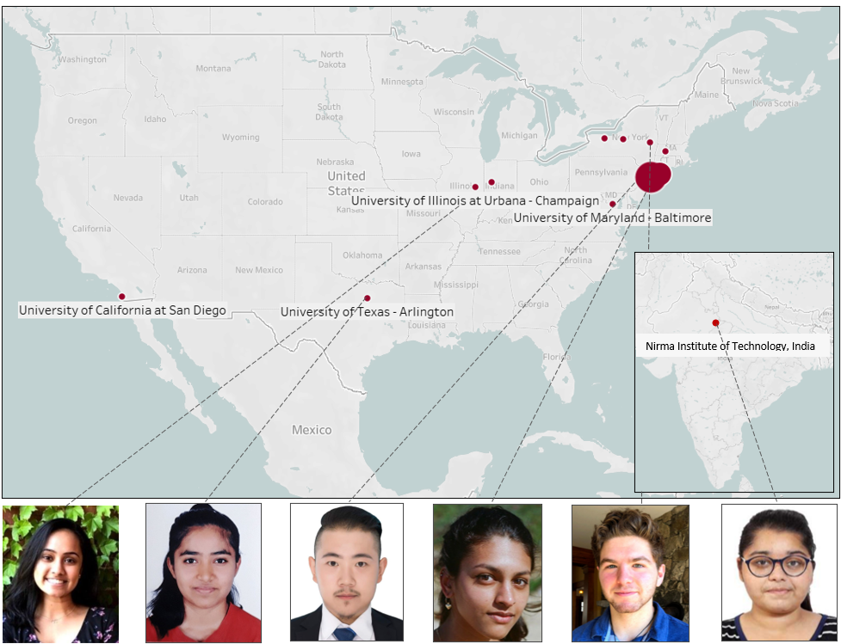
Cray Case
Union College, NY
Neha Shinde
UT Arlington, Texas
Yashvi Shah
Nirma Institute of Technology, Ahmedebad, India
Mayuri Raganathan
NYU, New York
Shan Jiang
Stevens Institute of Technology, New Jersey
Kath Nancy Paul
Loyola University Chicago

Fostering Multi-Disciplinary Research and Collaborations at Bronx Community College

After months of hard work, Dr. Sunil Bhaskaran, the director of the center, collaborated with Amazon and L3Harris, and CUNY, along with grants from the National Science Foundation and NASA to create a cloud-based geospatial computing server. On this server, we were able to hold the middle, high school, and professional development programs, as well as certain intern research projects on the cloud.

Dr. Sunil Bhaskaran was also invited to the International Conference (Online)Under the Aegis of UGC-DRS SAP-I Program On Building Resilient and Sustainable Societies: Emerging Social and Economic Challenges November 25-26, 2020, where he was a member of the advisory board.

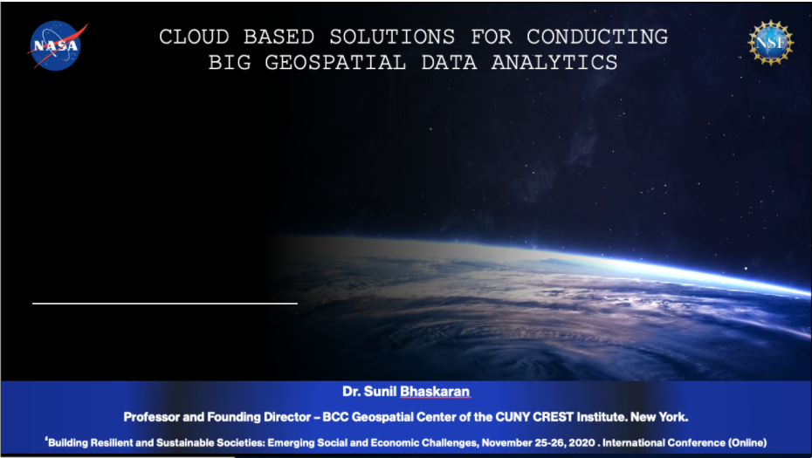

Grant Awards

(2020) Planning for the Post COVID-19 disaster. Cloud-computing solutions for delivering technology courses and workshops in the distance learning mode [Collaboration with Amazon Web Services]
[$63,173] NSF-ATE.

(2020) Planning for the POST COVID-19 disaster. *Cloud computing solutions for delivering technology courses and workshops in distance learning mode. [Collaboration with Industry – Amazon]. ($58,000) NASA.​

Creating a Virtual Environment for Activities in Collaboration with AWS

Switching to a distance-learning mode for delivering computer-based geospatial technology workshops was a challenge, especially during a pandemic like COVID-19. The ongoing National Science Foundation’s Advanced Technological Education [NSF-ATE] project at the City University of New York [CUNY] focuses on creating skilled geospatial technicians and building career pathways. Since its inception in 2017 the project has impacted over 400 students, faculty and educators, and through its research internship program trained several interns in applying geospatial technology for their multidisciplinary projects. The hands-on computer based workshops and research internships are usually held at the state-of-the-art geospatial computer center located on campus in the Bronx, New York City. However due to the pandemic we were unable to deliver it as planned, and were required to innovate in alternate modes of delivery. Inquiry based all year round workshops and research internships are an integral part of the project activities. The workshops and research internships involved the analyses of BIG geospatial satellite data that demanded a superior computing environment, which personal desktops or laptops don’t possess. There were several workshops, professional development activities and research internships that remain to be conducted under the ongoing NSF-ATE project at CUNY [2017-2021]. The university had limited infrastructure to offer the project activities in the distance-learning mode. The solution to this was a server in the cloud that could remotely host geospatial technology.

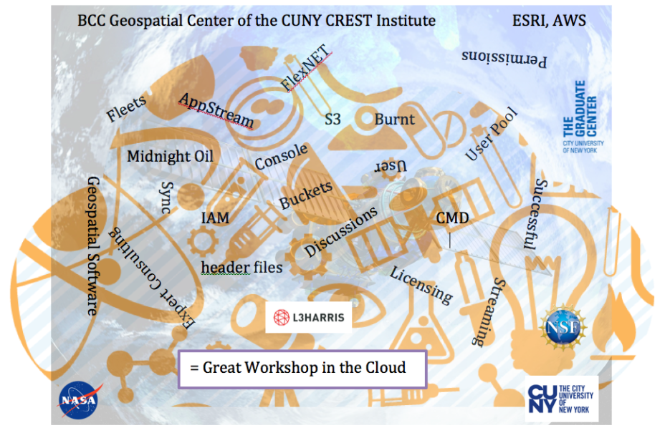
A cloud-computing environment offered superior services such BIG data analytics, user-friendly data management, processing speed and unmatched security compliance. Cloud computing enabled participants to realize the true potential of geospatial applications in real-world scenarios and assisted in the complete realization of programmatic goals that federal sponsors like NSF champion. However, leading cloud providers didn’t have ready-made templates that could be used immediately. Customization of cloud-computing platform is critical to match user requirements, which takes advanced planning, consumes time and demands coordination. The CUNY NSF-ATE project team tested the AWS Application Streaming module with then S3 [Supply, Storage and Service] architecture for the ongoing undergraduate geospatial workshops. Since May 2020 the efforts by the project team led by Dr. Sunil Bhaskaran in collaboration with the industry yielded promising results. Whilst AWS supported BGCCCI with a grant [free credits], L3 Harris Geospatial and Environmental Systems Research Institute [ESRI] supported BGCCCI with curriculum grants worth suites of software licenses, tech support and sample geospatial data. The workshops being assessed and evaluated by the external evaluator.

Throughout 2020 and 2021, the AWS has and is currently being utilized to provide high quality workshops and research experiences to students across the nation. The flexibility of the cloud computing software has allowed for more flexibility and talent than our previous in person programs have allowed. We have had students from California, Illinois, Texas, and even internationally in India study at BGCCCI.

How do BGCCCI activities align to BCC-CUNY Strategic Plans and Goals?

The overarching vision of Bronx Community College is to effectively invest in each student’s success by engaging with them in an integrative and supportive environment that facilitates the development and achievement of their educational and career goals. Graduates will be prepared to understand, thrive in, and contribute to a 21st - century global community marked by diversity, change, and expanded opportunities for lifelong learning and growth. Since its inception, BGCCCI has been demonstrating that all activities conducted by it in the past were aligned with this overarching institutional plan. The following goals are outlined below, and all of BGCCCI’s future plans are intended to align with one or more of these goals. As the center has been awarded major grants from NSF and NASA, along with the high success rate in getting external funds, the proposed collaborations will help the center to grow further and create a unique brand image within the College University of New York system, and within the NYC Metropolitan region.

Description of Proposed Activities | Alignment to BCC-CUNY Strategic Plans
Fostering multidisciplinary projects  with BCC academic departments. | Goal #3: Deepen student learning {Promotes integrated faculty learning, promotes and encourage excellent teaching and scholarship.
Undertaking cutting-edge  undergraduate & graduate research projects with internal and external clients. | Goal #3: Promote and encourage excellent teaching and scholarship.
Workshops for middle and high schools. | Goal #3: Deepen student learning {Promotes integrated faculty learning, promotes and encourage excellent teaching and scholarship.
Expert workshops for BCC students. | Goal #5: Cultivate a 21st Century Curriculum {strengthen program outcomes by maintaining formal linkages with four-year colleges and industry.
Delivering workshops for the community | Goal #7: Promote a reputation for excellence  1. Build and promote a brand around a learning-centered culture.  2. Promote pride in BCC.  3. Engage faculty, staff, students, alumni and supporters in telling  their BCC success stories.  4. Illustrate BCC as a premier institution with branding messages  and media sources.
Internships, Workshops, and International Conferences | Goal 7: Promote a reputation for excellence  1. Build and promote a brand around a learning-centered culture.  2. Promote pride in BCC.  3. Engage faculty, staff, students, alumni and supporters in telling their BCC success stories.  4. Illustrate BCC as a premier institution with branding messages and media sources.

Goal 1: BGCCCI BUILDS A COMMUNITY OF EXCELLENCE.
• Implement and carry out Workshops for Middle, High, and Undergraduate Students, as well as Professional Educators and members of the community.
• Provides opportunities for Graduate and Undergraduate students to work in BCC Geospatial Center of the CUNY Crest Institute and acquire workforce skills.
• Collaborates with an Industry consortium to design curricula, programs out-of-the-box Internships and career pathways.
• Designing, developing and introducing new and multidisciplinary courses/programs in geospatial technology.
• Fostering and Increasing Participation in Geospatial Technology and STEM for a diversity of underrepresented groups.

Goal 2: BGCCCI EMPOWERS STUDENTS TO SUCEED IN THEIR CHOSEN CAREERS OR HIGHER EDUCATION.
• Guest Speakers from Industry relating to Geospatial Technology speak with Workshop participants regarding furthering education and career pathways. • Allow student participation and hands on training in Geospatial Technology.
• Teach geospatial application skills, furthering knowledge in various areas with implications to further career and education paths.
See Link >>> http://www.bcc.cuny.edu/academics/geospatial-center-of-the-cuny-crestinstitute/bgccci-advisory-board/

Goal 3: BGCCCI DEEPENS STUDENT LEARNING.
• Conducting scholarly activities and cutting-edge research in areas of national priority.
• Training students in acquiring workforce skills by organizing summer institutes for school and college students.
• Creating innovative pathways in geospatial technology and career pathways.
• Publishing in peer-reviewed journals and proceedings of conferences.

Goal 4: BGCCCI DEVELOPS WORLD CITIZENS.
• Students conduct research using satellite data and geographic data on translational topics of global importance such as Urbanization, Land Cover, Feature Extraction, BIG Data analytics.
• Affiliated faculty and students at BGCCCI and other institutions across the nation connected through BGCCCI and the learning of geospatial technology.

Goal 5: BGCCI CULTIVATES A 21ST CENTURY CURRICULUM.
• Promotes education and research in emerging Geospatial Technology.
• Affiliated faculty at BGCCCI design curriculum that is focused on place-based, hands-on learning experiences that enhance spatial thinking and cognition in key areas of geographic information systems, remote sensing, and global positioning systems.
• Geospatial Pathway courses have a cumulative enrollment of approximately 300 students since Fall 2015

Goal 6: BGCCCI ENHANCES THE CAMPUS ENVIRONMENT.
• Promotes cutting-edge research using data from the office of Institutional research to create interactive user friendly spatial information systems.
• Show a replicable model of space and resource usage versus measurable outcomes.
• Use of the Geospatial Center in optimally carrying out workshops, and research.

Goal 7: BGCCCI PROMOTES A REPUTATION FOR EXCELLENCE.
• Affiliated faculty and experts mentor students in cutting-edge research.
• Affiliated faculty conduct cutting-edge research that is published in peer-reviewed journals.
• Affiliated faculty has a high success ratio in securing grant funding from federal and private agencies.
• Affiliated faculty deliver presentations at departments to foster multi-disciplinary applied research.
• New curricula, programs, hands-on learning materials using industry standard suite of software and satellite data.
• Interns from other institutions conduct cutting-edge research
• Guest lectures by experts in the Industry.
• History of collaborating with an Industry consortium to create career pathways.
• Collaborate with all stake holders to increase participation of underserved communities and inclusiveness in geospatial technology.
• Hosts information sessions and workshops for visiting delegations including Fulbright Scholars, and dignitaries

Budget – Fiscal 2021

Budget Category | Details | Total Amount | Funding from College | Funding from CUNY | Funding from Grants and Awards | Other Funds
Personnel
Director | Summer Salary [Includes $37,635 from federal grants + adjunct replacement at $4,530 per course] | $55,755 | $18,120 Reassigned time of 12hr. [6hrs for spring and 6hrs for Fall] from OAA | - | $37,635 | -
Staff | Administrative Support [To assist the director in managing the geospatial center and two major federal grants for the College] | $41,235 | $15,600 | - | $25,635 | -
Stipends |  | $96,990 | $33,720 |  | $63,270
Total Personnel | - | - | - | - | - | -
Other than Personnel Services (OTPS) | - | - | - | - | - | -
Travel | - | $9,470 | - | - | $9,470 | -
Stipends | For participants in NSF & NASA workshops | $255,900 | - | - | $255,900 | -
Equipment | - | - | - | - | - | -
Supplies | - | - | - | - | - | -
Other | - | - | - | - | - | -
Total OTPS |  | $287,846 |  |  | $287,846

BGCCCI Assessment Metrics

All activities are assessed by using formative and summative model of assessment. Activities are evaluated and assessed by assessment metrics (see below) as well as by an external evaluator.

Description of Activities | Assessment Mode
- Workshops and training | Survey
- Research | Publications – journals, reports, conference presentations
- Seminars | Survey
- Internships | Project completion
- Sponsored Events | Survey & Feedback form
- Geospatial Computing Center | Space use
- International Collaborations | Project results, publications, reports
- National Collaborations | Project results, publications, reports
- Center support for college and CUNY | Survey
- External Grants | Grants Awarded

BGCCCI Quick Look fact sheet [2014-]

BCC Geospatial Center of the CUNY CREST Institute [BGCCCI] is a unit under the Office of Academic Affairs. Reports to the Interim Provost of BCC-CUNY – Dr. Luis Montenegro

141 Middle School Workshop participants
155 High School Workshop participants
31 Undergraduate Workshop participants
59 SWIP Research Interns
35 Professional Development Workshop participants

421 Total Participants

Founding Director – Professor Sunil Bhaskaran
Web site: http://www.bcc.cuny.edu/academics/geospatial-center-of-the-cuny-crest-institute/
Twitter @BGCCCIGeo
Coordinator: Andrella Collins
Research Associate: Hoatian Fang

Bolstering the countries workforce skills – 6-10 weeks intensive all-round Research Internship program

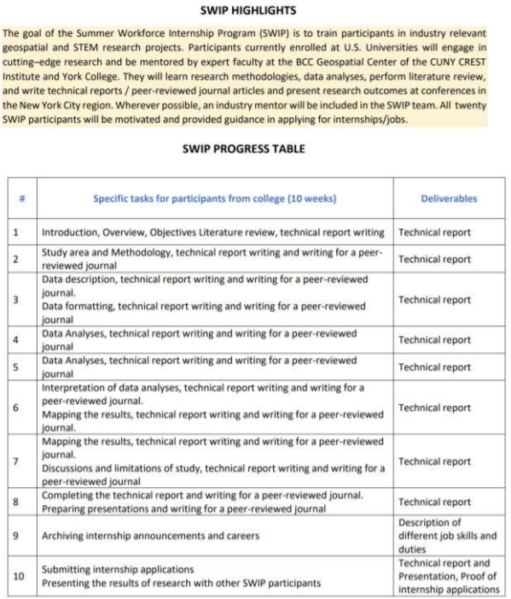

Intern Process Flow Chart

