BCC GEOSPATIAL CENTER OF THE CUNY CREST INSTITUTE
[Office of Academic Affairs]

Annual Report
2019 - 2020

Activities
Summer 2019

Over the course of 16 days, middle, high school, and university workshop participants were trained in GIS and modeling, digitization and geoprocessing, spatial analysis in health, education, and environmental sciences, as well as network analysis and modeling spatial data. These workshops not only exposed, but enthused and trained participants from under-represented communities and resource poor institutions in geospatial technology. At each level, these workshops help to build a foundational knowledge of geospatial technology that can be built upon in the higher levels, and later in life in professional settings. All participants completed their hands-on exercises using industry standard software. They presented their respective research projects on the final day of the workshop. All participants were required to submit daily evaluation reports.

During the 2019 Summer Workforce Internship Program, 20 interns at both the high school and university level were able to research topics related to geospatial technology, which cumulated in technical reports, tutorials, and presentations. Using industry standard software, as well as being mentored by expert faculty and staff, students presented research that ranged from measuring quality of life to evaluating the effectiveness of restorative plantings.

Educators and teachers in STEM fields were introduced geospatial technology via our 2019 Professional Development Workshop from 8/5 to 8/16. The participants were exposed to concepts in remote sensing, different types of satellite imagery, and were trained in image analyses using industry standard software. Participants were encouraged to brain-storm new projects in geospatial technology and provided innovative solutions to beat challenges around acquisition of software and geospatial datasets. As a result of this workshop, the educators are now able to introduce these geospatial concepts to their respective students across the country and instill this knowledge in younger generations.

Fall 2019

In the fall 2019 workshops, middle and high school students within the New York City Metropolitan area were afforded the opportunity to develop foundational knowledge of geospatial technology. Over the course of the 10 week program that was held every Saturday, participants were trained in GIS and modeling, digitization and geoprocessing, spatial analysis, and network analysis. Our instructors trained them in spatial analyses by a combination of lectures and inquiry based hands-on exercises designed with a place-based approach. All participants completed their exercises using industry standard software and attended a presentation from an industry professional. They presented their respective research projects on the final day of the workshop.

Spring 2020
Although the Center had to cancel the Middle and High School workshops, Dr. Sunil Bhaskaran, the director of the center, worked with the Industry Consortium to ensure that our programs could be delivered remotely. Thanks to Amazon, NASA, and NSF, BGCCCI was able to create a cloud-based server to host programs where participants could access geospatial technology
Fostering Multi-Disciplinary Research and Collaborations at Bronx Community College

Dr. Sunil Bhaskaran and BGCCCI members was invited to the NASA Mega PI Meet in Cleveland Ohio, the ENVI Analytic Symposium, and the NSF-ATE PI Conference in 2019.

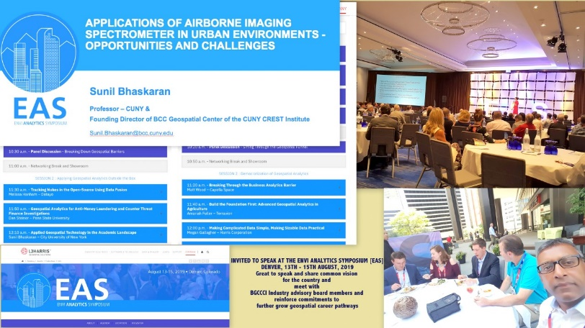
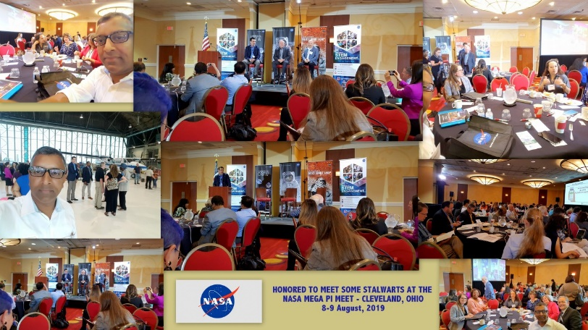
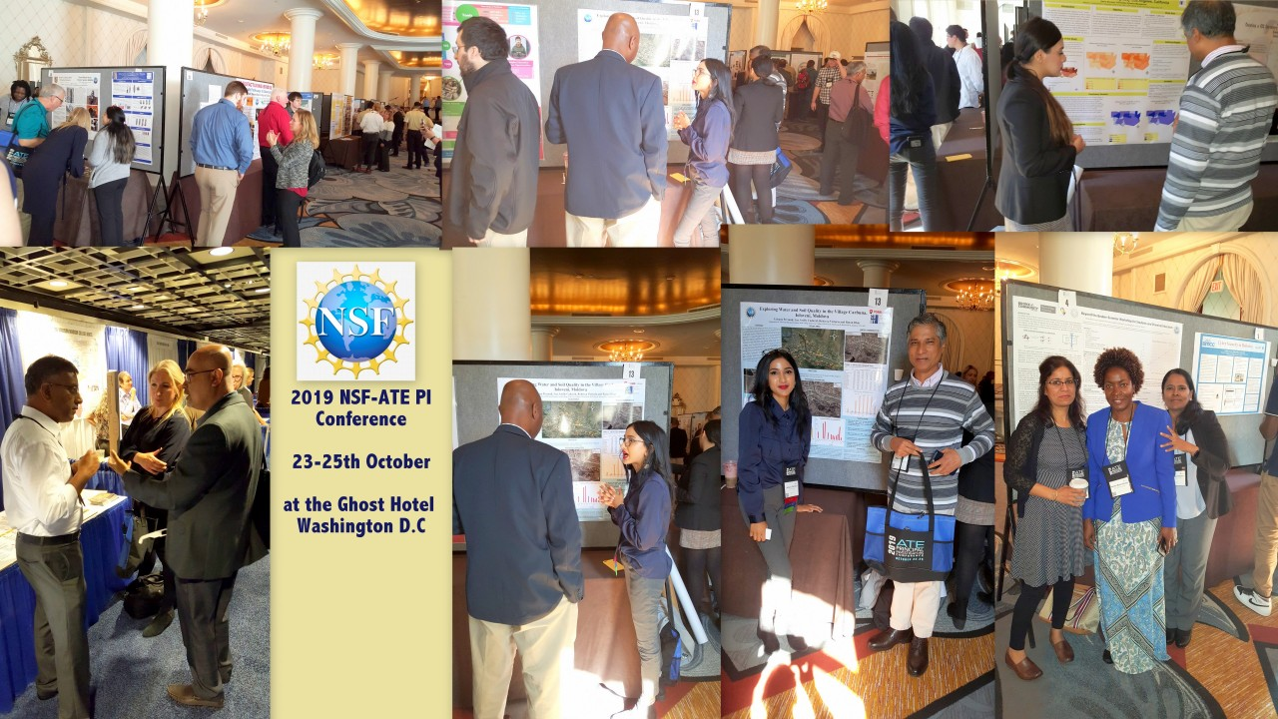

Grant Awards

(2020) Planning for the Post COVID-19 disaster. Cloud-computing solutions for delivering technology courses and workshops in the distance learning mode [Collaboration with Amazon Web Services]
[$63,173] NSF-ATE.

(2020) Planning for the POST COVID-19 disaster. *Cloud computing solutions for delivering technology courses and workshops in distance learning mode. [Collaboration with Industry – Amazon]. ($58,000) NASA.​

How do BGCCCI activities align to BCC-CUNY Strategic Plans and Goals?

The overarching vision of Bronx Community College is to effectively invest in each student’s success by engaging with them in an integrative and supportive environment that facilitates the development and achievement of their educational and career goals. Graduates will be prepared to understand, thrive in, and contribute to a 21st - century global community marked by diversity, change, and expanded opportunities for lifelong learning and growth. Since its inception, BGCCCI has been demonstrating that all activities conducted by it in the past were aligned with this overarching institutional plan. The following goals are outlined below, and all of BGCCCI’s future plans are intended to align with one or more of these goals. As the center has been awarded major grants from NSF and NASA, along with the high success rate in getting external funds, the proposed collaborations will help the center to grow further and create a unique brand image within the College University of New York system, and within the NYC Metropolitan region.

Description of Proposed Activities | Alignment to BCC-CUNY Strategic Plans
Fostering multidisciplinary projects  with BCC academic departments. | Goal #3: Deepen student learning {Promotes integrated faculty learning, promotes and encourage excellent teaching and scholarship.
Undertaking cutting-edge  undergraduate & graduate research projects with internal and external clients. | Goal #3: Promote and encourage excellent teaching and scholarship.
Workshops for middle and high schools. | Goal #3: Deepen student learning {Promotes integrated faculty learning, promotes and encourage excellent teaching and scholarship.
Expert workshops for BCC students. | Goal #5: Cultivate a 21st Century Curriculum {strengthen program outcomes by maintaining formal linkages with four-year colleges and industry.
Delivering workshops for the community | Goal #7: Promote a reputation for excellence  1. Build and promote a brand around a learning-centered culture.  2. Promote pride in BCC.  3. Engage faculty, staff, students, alumni and supporters in telling  their BCC success stories.  4. Illustrate BCC as a premier institution with branding messages  and media sources.
Internships, Workshops, and International Conferences | Goal 7: Promote a reputation for excellence  1. Build and promote a brand around a learning-centered culture.  2. Promote pride in BCC.  3. Engage faculty, staff, students, alumni and supporters in telling their BCC success stories.  4. Illustrate BCC as a premier institution with branding messages and media sources.

Goal 1: BGCCCI BUILDS A COMMUNITY OF EXCELLENCE.
• Implement and carry out Workshops for Middle, High, and Undergraduate Students, as well as Professional Educators and members of the community.
• Provides opportunities for Graduate and Undergraduate students to work in BCC Geospatial Center of the CUNY Crest Institute and acquire workforce skills.
• Collaborates with an Industry consortium to design curricula, programs out-of-the-box Internships and career pathways.
• Designing, developing and introducing new and multidisciplinary courses/programs in geospatial technology.
• Fostering and Increasing Participation in Geospatial Technology and STEM for a diversity of underrepresented groups.

Goal 2: BGCCCI EMPOWERS STUDENTS TO SUCEED IN THEIR CHOSEN CAREERS OR HIGHER EDUCATION.
• Guest Speakers from Industry relating to Geospatial Technology speak with Workshop participants regarding furthering education and career pathways. • Allow student participation and hands on training in Geospatial Technology.
• Teach geospatial application skills, furthering knowledge in various areas with implications to further career and education paths.
See Link >>> http://www.bcc.cuny.edu/academics/geospatial-center-of-the-cuny-crestinstitute/bgccci-advisory-board/

Goal 3: BGCCCI DEEPENS STUDENT LEARNING.
• Conducting scholarly activities and cutting-edge research in areas of national priority.
• Training students in acquiring workforce skills by organizing summer institutes for school and college students.
• Creating innovative pathways in geospatial technology and career pathways.
• Publishing in peer-reviewed journals and proceedings of conferences.

Goal 4: BGCCCI DEVELOPS WORLD CITIZENS.
• Students conduct research using satellite data and geographic data on translational topics of global importance such as Urbanization, Land Cover, Feature Extraction, BIG Data analytics.
• Affiliated faculty and students at BGCCCI and other institutions across the nation connected through BGCCCI and the learning of geospatial technology.

Goal 5: BGCCI CULTIVATES A 21ST CENTURY CURRICULUM.
• Promotes education and research in emerging Geospatial Technology.
• Affiliated faculty at BGCCCI design curriculum that is focused on place-based, hands-on learning experiences that enhance spatial thinking and cognition in key areas of geographic information systems, remote sensing, and global positioning systems.
• Geospatial Pathway courses have a cumulative enrollment of approximately 300 students since Fall 2015

Goal 6: BGCCCI ENHANCES THE CAMPUS ENVIRONMENT.
• Promotes cutting-edge research using data from the office of Institutional research to create interactive user friendly spatial information systems.
• Show a replicable model of space and resource usage versus measurable outcomes.
• Use of the Geospatial Center in optimally carrying out workshops, and research.

Goal 7: BGCCCI PROMOTES A REPUTATION FOR EXCELLENCE.
• Affiliated faculty and experts mentor students in cutting-edge research.
• Affiliated faculty conduct cutting-edge research that is published in peer-reviewed journals.
• Affiliated faculty has a high success ratio in securing grant funding from federal and private agencies.
• Affiliated faculty deliver presentations at departments to foster multi-disciplinary applied research.
• New curricula, programs, hands-on learning materials using industry standard suite of software and satellite data.
• Interns from other institutions conduct cutting-edge research
• Guest lectures by experts in the Industry.
• History of collaborating with an Industry consortium to create career pathways.
• Collaborate with all stake holders to increase participation of underserved communities and inclusiveness in geospatial technology.
• Hosts information sessions and workshops for visiting delegations including Fulbright Scholars, and dignitaries

Budget – Fiscal 2020

Budget Category | Details | Total Amount | Funding from College | Funding from CUNY | Funding from Grants and Awards | Other Funds
Personnel
Director | Summer Salary [Includes $37,635 from federal grants + adjunct replacement at $4,530 per course] | $55,755 | $18,120 Reassigned time of 12hr. [6hrs for spring and 6hrs for Fall] from OAA | - | $37,635 | -
Staff | Administrative Support [To assist the director in managing the geospatial center and two major federal grants for the College] | $41,235 | $15,600 | - | $25,635 | -
Stipends |  | $96,990 | $33,720 |  | $63,270
Total Personnel | - | - | - | - | - | -
Other than Personnel Services (OTPS) | - | - | - | - | - | -
Travel | - | $9,470 | - | - | $9,470 | -
Stipends | For participants in NSF & NASA workshops | $255,900 | - | - | $255,900 | -
Equipment | - | - | - | - | - | -
Supplies | - | - | - | - | - | -
Other | - | - | - | - | - | -
Total OTPS |  | $287,846 |  |  | $287,846

BGCCCI Assessment Metrics

All activities are assessed by using formative and summative model of assessment. Activities are evaluated and assessed by assessment metrics (see below) as well as by an external evaluator.

Description of Activities | Assessment Mode
- Workshops and training | Survey
- Research | Publications – journals, reports, conference presentations
- Seminars | Survey
- Internships | Project completion
- Sponsored Events | Survey & Feedback form
- Geospatial Computing Center | Space use
- International Collaborations | Project results, publications, reports
- National Collaborations | Project results, publications, reports
- Center support for college and CUNY | Survey
- External Grants | Grants Awarded

Founding Director – Professor Sunil Bhaskaran
Web site: http://www.bcc.cuny.edu/academics/geospatial-center-of-the-cuny-crest-institute/
Twitter @BGCCCIGeo
Part time Staff:
Full Time Staff:

Photo Feature – Summer 2019

